1. Git init (Initialization)
2. Git status
3. Git add –a (to add the file / staging area)
4. Git commit –m (m -> message)

Ex: git commit -m “Final Score”

1. Git config –global user.name “your name”
2. Git config –global user.email “your email”
3. Git clone “url”

Ex: git clone [https://github.com/shreyanshtripathi-01/trial-repo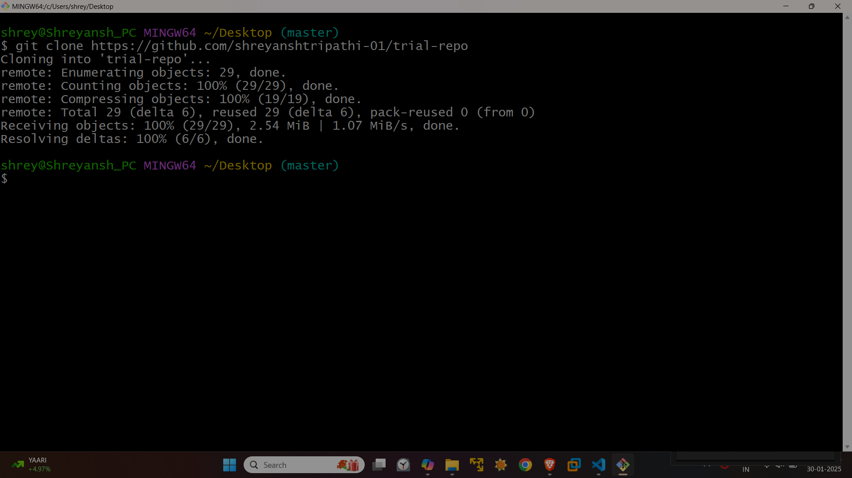](https://github.com/shreyanshtripathi-01/trial-repo)

1. Git push